Turnitin Assignment Submission in LMS Course

- Login to LMS (lms.nust.edu.pk/portal)
- Open your course, you want to make a submission.
- Click on the Turnitin assignment link available in your course.
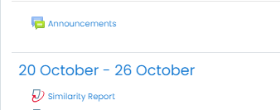
- Choose the assignment part, you need to make submission.
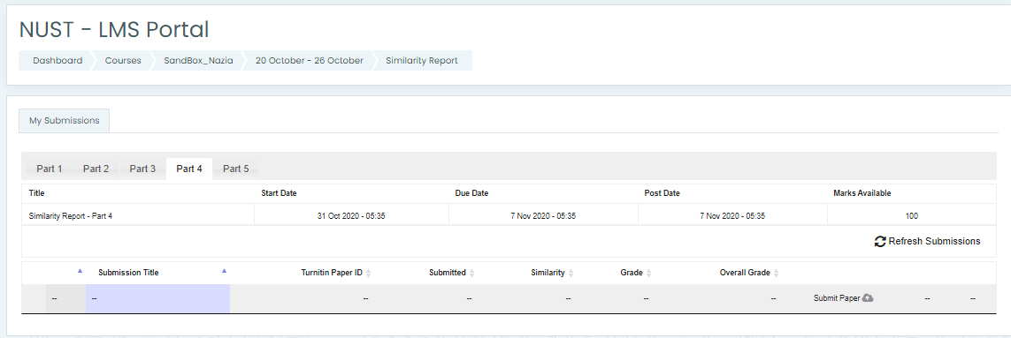
- Choose the “Submission type” to choose whether you want to submit the online text or upload a file for the assignment.
- Write the title for submission and upload the file using file picker or drag and drop and add the submission.

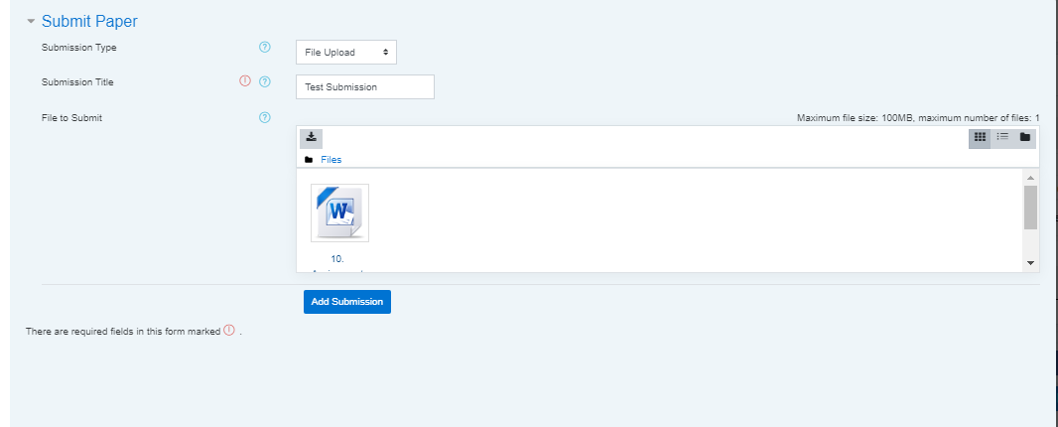
- Click on the close button to return to the assignment main page.
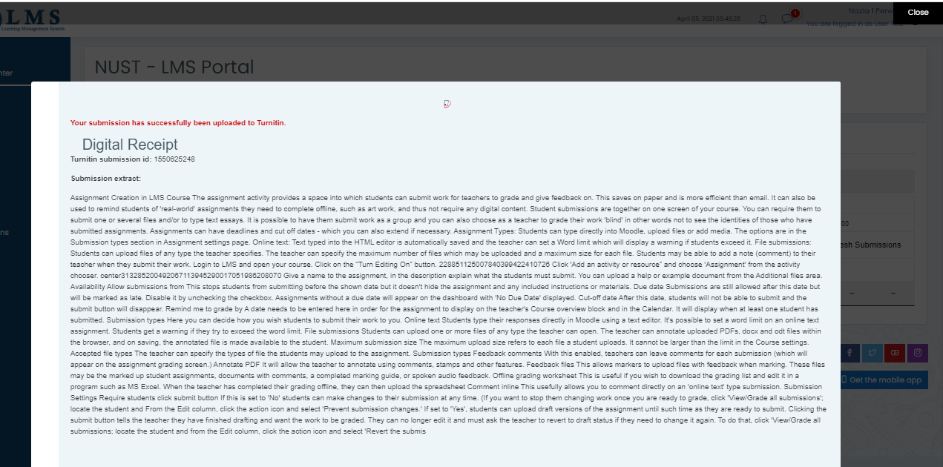
- Right after submission, the pending status will appear for similarity index. After few minutes of submission, click on “Refresh submissions” button. (As per Turnitin policy, the similarity report generation takes 24 hours for every re-submission, however the first report is generated in lesser time)
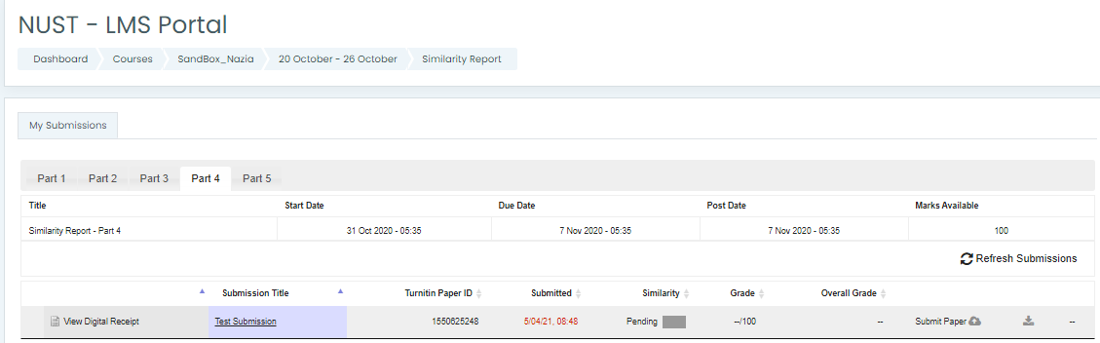
- After processing of the document and generation of the similarity report, the pending status will be updated with actual similarity index in percentage/ fraction along with a colored bar.
- Click on the colored bar to open the similarity report.
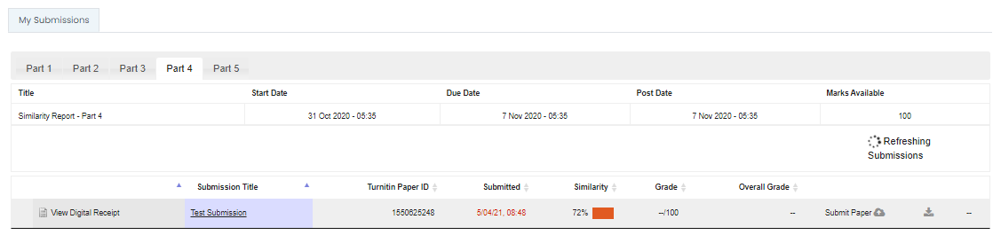
- Click on the percentage (i.e. 72 in the following image) to expand the list of similar documents.
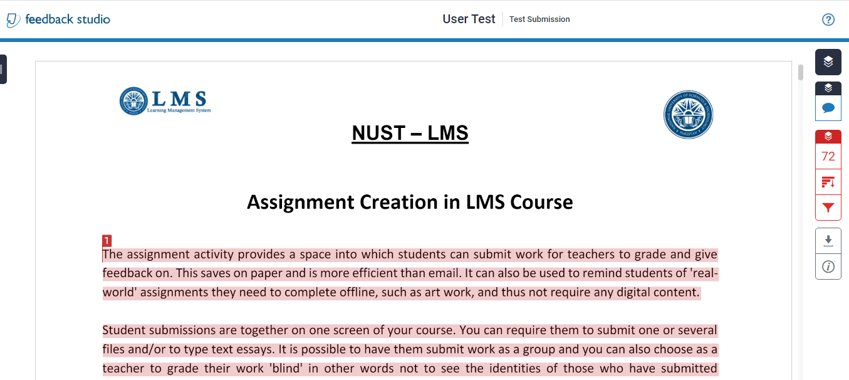
- Click on the download icon to download the similarity report.
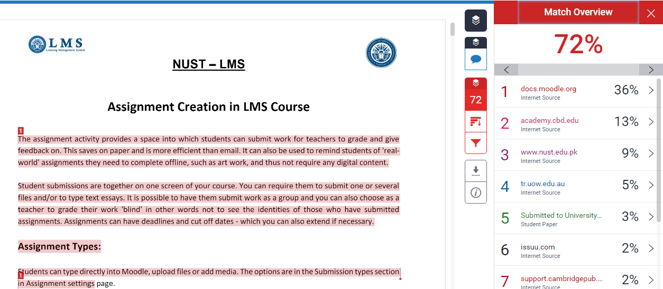
- You can download the detailed similarity report by clicking on the download arrow of “Current view” and the summarized digital receipt by clicking on “Digital receipt”.

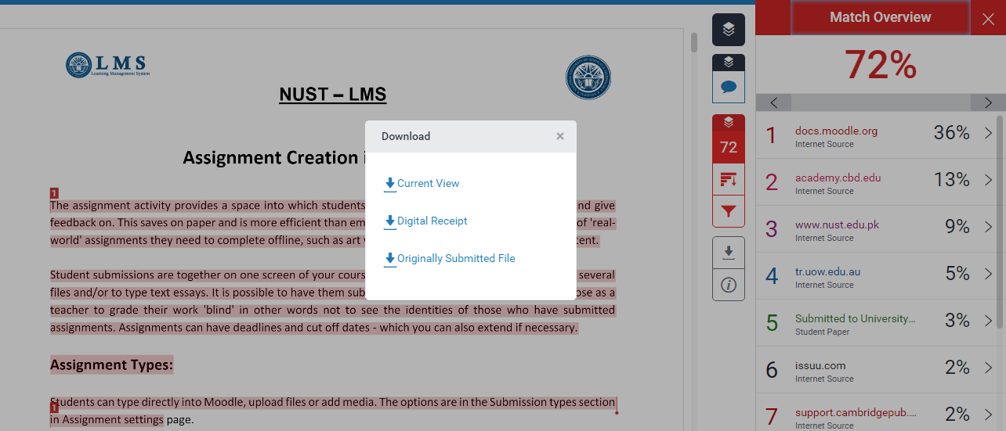

A sample of digital receipt is given below:
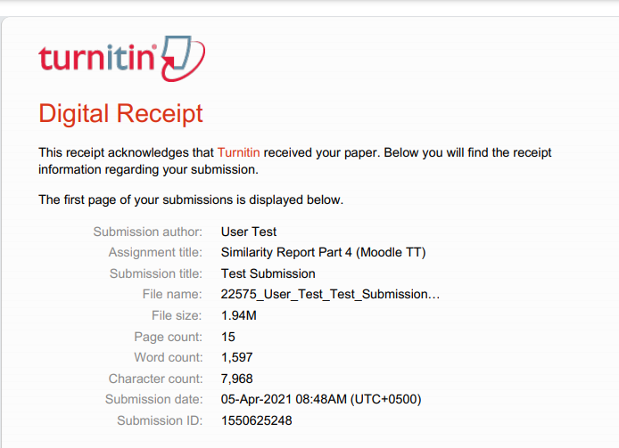
A sample of detailed similarity report, downloaded in PDF format is given below:



